Workshop for Protein Complexes and Quantitative Proteomics: Theory, Computation and Experiment
蛋白质复合物和定量蛋白质组学：
理论、计算与实验研讨会

时间：2020年11月14-15日
地点：中国人民大学数学学院二层报告厅
会议形式：线下+线上
- 腾讯会议/VooV meeting：
14日ID: 895437440, Passwd:1114 ; 15日ID: 827664470, passwd: 1115
- 虎牙直播地址： https://www.huya.com/bioinformatics

主办单位：中国人民大学数学学院
中国人民大学数学科学研究院
支持单位：中国计算机学会生物信息学专业委员会
中国运筹学会计算系统生物学分会

会议册目录

会议日程安排 - 1 -
报告题目及摘要Talk Title and Abstract - 3 -
腾讯会议软件教程 - 22 -
How to use VooV Meeting? - 26 -
报告人住宿交通 - 31 -
校外老师及学生参会指南： - 33 -
校内 Wi-Fi 使用指南 - 34 -

会议日程安排
2020年11月14日 周六
Saturday, 14 November 2020

08:15-08:30 领导致辞 Welcome Remarks
Session 1 Chair: 卢本卓（中科院数学院）
08:30-09:20 | 陈洛南  （中科院上海） |  | Causal inference from high-dimensional data
09:20-10:10 | Mohammed AlQuraishi  （Columbia University） |  | Machine-learned molecular models for a bottom-up systems biology
10:10-10:20 茶歇
Session 2 Chair: 周如鸿（浙江大学）
10:20-11:10 | 王新泉  （清华大学） | Structural insights into the evolution, infection and inhibition of highly pathogenic human coronaviruses
11:10-12:00 | 杨茂君  （清华大学） | 呼吸的分子基础
12:00-12:30 | 吴更  （上海交大） | 结节性硬化症蛋白复合物的结构及功能研究
午餐（中国人民大学汇贤食府）
Session 3 Chair: 龚海鹏（清华大学）
14:00-14:50 | 王志新  （苏州大学） | New structural insights into the kinase binding domain of MKP3 and its interaction with ERK2
14:50-15:40 | 周如鸿  （浙江大学） | Immunotherapy Modeling: Molecular Interaction and Recognition of MHC/peptide/TCR Complexes
15:40-15:50 茶歇
Session 4 Chair: 田瑞军（南方科大）
15:50-16:20 | 邓海腾  （清华大学） | Beyond Expression Proteomics: Probing Protein Functional Diversity in Cellular Processes
16:20-17:10 | 郭天南  （西湖大学） | 临床蛋白质组学最新进展
17:10-18:00 | 于晓波  （国家蛋白质中心） | 新冠疫情下的血液蛋白质组学研究
晚餐（中国人民大学汇贤食府）
Session 5 Chair: 李春华（北工大）
19:10-20:00 | 黄胜友  （华中科大） | Protein-Protein Contact Prediction and Its Application in Modeling Protein Homo-Oligomer Structures
20:00-20:30 | 卜东波  （中科院计算所） | ProALIGN: Directly learning alignments for protein structure prediction via exploiting context-specific alignment motifs
20:30-21:00 | 卢本卓  （中科院数学院） | 分子几何相关的一些研究及应用
2020年11月15日 周日
Sunday, 15 November 2020

Session 1 Chair: Dima Kozakov（Stony Brook University, New York）
08:30-09:20 |  | Jinbo Xu  （TTIC） | Latest development of deep learning for protein folding
09:20-10:10 |  | Huanxiang Zhou  (UIC) | Regulation of Thermodynamic and Material Properties of Biomolecular Condensates by Intermolecular Interactions
10:10-10:20 茶歇
Session 2 Chair: Jinbo Xu（Toyota Technological Institute at Chicago）
10:20-11:10 |  | Haiyuan Yu  （Cornel U） | Mapping protein interactions with structural details on the whole proteome scale
11:10-11:40 |  | Dima Kozakov  （Stony Brook U） | Modeling and modulation of macromolecular interactions
11:40-12:10 |  | 李春华  （北工大） | Study and prediction on protein-RNA recognition interfaces and complex structures
午餐（中国人民大学汇贤食府）
Session 3 Chair: 黄胜友（华中科大）
14:00-14:50 |  | 高宁  （北京大学） | Structural Aspects of Ribosome Biogenesis and Translation Regulation
14:50-15:40 |  | 田瑞军  （南方科大） | 基于生物质谱技术的时空动态蛋白质复合物分析及生物医学应用
15:40-15:50 茶歇
Session 4 Chair: 卜东波（中科院计算所）
15:50-16:40 |  | 龚海鹏  （清华大学） | Protein inter-residue distance prediction and enhanced sampling
16:40-17:30 | Dina Schneidman  (Hebrew University) |  | Macromolecular structure and dynamics based on cross-links
17:30-18:00 |  | 苏计国  （燕山大学） | The functional motions and key residues behind the uncoating of coxsackievirus A16 revealed by elastic network model combined with group theory
18:00-18:30 |  | 龚新奇  (中国人民大学) | Functional multimer protein-protein interaction complex structure prediction by machine learning approaches
晚餐（中国人民大学汇贤食府）

报告题目及摘要Talk Title and Abstract

Title: Causal inference from high-dimensional data
(基于生物高维数据的因果推断方法)
陈洛南 中科院上海生化所

Abstract: Causality detection likely misidentifies indirect causations as direct ones, due to the effect of causation transitivity. Although several methods in traditional frameworks have been proposed to avoid such misinterpretations, there still is a lack of feasible methods for identifying direct causations from indirect ones in the challenging situation where the variables of the underlying dynamical system are non-separable and weakly or moderately interacting. Here, we solve this problem by developing a data-based, model-independent method of partial cross mapping based on an articulated integration of three tools from nonlinear dynamics and statistics: phase-space reconstruction, mutual cross mapping, and partial correlation. We demonstrate our method by using data from different representative models and real-world systems, such as biological systems. As direct causations are keys to the fundamental underpinnings of a variety of complex dynamics, we anticipate our method to be indispensable in unlocking and deciphering the inner mechanisms of real systems in diverse disciplines from data. The publications can be referred to https://doi.org/10.1038/s41467-020-16238-0.
Bio: Luonan Chen received BS degree in the Electrical Engineering, from Huazhong University of Science and Technology, and the M.E. and Ph.D. degrees in the electrical engineering, from Tohoku University, Sendai, Japan, in 1988 and 1991, respectively. From 1997, he was an associate professor of the Osaka Sangyo University, Osaka, Japan, and then a full Professor. Since 2010, he has been a professor and executive director at Key Laboratory of Systems Biology, Shanghai Institute of Biochemistry and Cell Biology, Chinese Academy of Sciences. He was elected as the founding president of Computational Systems Biology Society of OR China, and Chair of Technical Committee of Systems Biology at IEEE SMC Society. In recent years, he published over 350 journal papers and two monographs (books) in the area of bioinformatics, nonlinear dynamics and machine learning.

Title: Machine-learned molecular models for a bottom-up systems biology

Mohammed AlQuraishi Columbia University

Abstract: The advent of a new modeling paradigm known as ‘differentiable programming’ makes possible bespoke machine-learned models of biological phenomena that are partly learned from data and partly informed by human-derived biophysical knowledge. In this talk I will describe three instantiations of this approach for predicting protein structure, protein-protein interactions, and protein function. Using these models, we have begun to uncover a combinatorial grammar underlying signal transducing proteins in metazoa. This grammar describes how modular protein interaction domains and their cognate binding sites combine to form units of functional logic that are widely reused throughout signaling networks. I will also describe how machine-learned models enable us to predict the effects of disease-causing mutations on the wiring of these signaling networks in human cancers. Looking ahead, I will conclude by considering the short and long-term prospects of integrating molecular models in a bottom-up fashion to assemble increasingly more accurate representations of biological systems that facilitate a principled and mechanistic approach to systems biology and precision medicine.
Bio: Mohammed AlQuraishi is an Assistant Professor in the Department of Systems Biology and a member of Columbia’s Program for Mathematical Genomics, where he works at the intersection of machine learning, biophysics, and systems biology. The AlQuraishi Lab focuses on two biological perspectives: the molecular and systems levels. On the molecular side, the lab develops machine learning models for predicting protein structure and function, protein-ligand interactions, and learned representations of proteins and proteomes. On the systems side, the lab applies these models in a proteome-wide fashion to investigate the organization, combinatorial logic, and computational paradigms of signal transduction networks, how these networks vary in human populations, and how they are dysregulated in human diseases, particularly cancer. Dr. AlQuraishi holds undergraduate degrees in Biology, Computer Science, and Mathematics. He earned an M.S. in Statistics and a Ph.D. in Genetics from Stanford University. He subsequently joined the Systems Biology Department at Harvard Medical School as a Departmental Fellow and a Fellow in Systems Pharmacology, where he developed the first end-to-end differentiable model for learning protein structure from data. Prior to starting his academic career, Dr. AlQuraishi spent three years founding two startups in the mobile computing space.

Title: Structural insights into the evolution, infection and inhibition of highly pathogenic human coronaviruses

Xinquan Wang
Beijing Advanced Innovation Center for Structural Biology, Beijing Frontier Research Center for Biological Structures, School of Life Sciences, Tsinghua University

Abstract: The highly pathogenic human coronaviruses SARS-CoV, MERS-CoV and SARS-CoV-2 have emerged during the past twenty years and posed severe threat to human health. The unprecedented COVID-19 pandemic caused by SARS-CoV-2 is currently devastating the world with 44 million infections and 1.2 million deaths. The spike (S) glycoprotein of coronaviruses plays critical roles in the infection by recognizing cellular receptor and mediating the fusion of virus and cell membranes. Its evolvement determines the tissue and cellular tropism and the zoonotic transmission of coronaviruses. The S glycoprotein is also the major target of host neutralizing antibodies. By determining the cryo-EM structures of the SARS-CoV S glycoprotein and its complex with ACE2 receptor, we revealed a conformational sampling of the S glycoprotein receptor-binding domain (RBD) as a prerequisite for receptor binding, not only for SARS-CoV, but also for MERS-CoV and SARS-CoV-2. We also determined crystal structures of MERS-CoV RBD bound to DPP4 receptor and SARS-CoV-2 RBD bound to ACE2 receptor, revealing the molecular basis of S-receptor interaction at atomic resolution. By determining and comparing the cryo-EM structures of bat RaTG13 and pangolin PCoV_GX coronavirus S glycoproteins, we provided important insights into the evolution of the SARS-CoV-2 S glycoprotein to gain highly efficient infection. Finally, we revealed diverse neutralizing epitopes and mechanisms of MERS-CoV and SARS-CoV-2 antibodies by studying their complex structures with respective RBDs. All above results greatly help to understand the structure and function of S glycoproteins and to guide the development of therapeutics and vaccines against the highly pathogenic human coronaviruses.
Bio: Dr. Xinquan Wang graduated from Fudan University in 1995 with B.Sc degree. He obtained his Ph.D. in the Institute of Biophysics, Chinese Academy of Sciences in 2000. After three years as a research associate in the same institute and five years as postdoc at Stanford University, he came back to the School of Life Sciences, Tsinghua University in 2008 as a tenure track associate professor and was promoted to a tenured professor in 2013. Dr. Wang’s group utilizes X-ray crystallography and other biochemical techniques to study how protein-protein interactions mediate the specific recognition of cytokines and growth factors by plasma membrane receptors, which is an important step in initiating cellular responses to the change of extracellular environment. Another growing interest in his group is structural and biochemical studies of protein complexes involved in virus-host interactions, especially in the cell entry of enveloped viruses and viral immune evasion.

Title：呼吸的分子基础
杨茂君 清华大学

Abstract：呼吸，是每一个个体乃至每一个细胞在其生命活动过程中不可或缺的基本过程，是人类近百年来一直在孜孜以求而探索的研究领域。细胞呼吸是在细胞内最重要的、为细胞提供能量的细胞器线粒体中进行的生命体最基本的生命活动之一。针对呼吸作用研究具有深远的理论研究意义和实际应用价值。一百多年来，对线粒体呼吸链的结构与功能研究一直都是国际生命科学领域的热点之一。彼得·米切尔（Peter D. Mitchell）曾于1978年因提出线粒体呼吸链的化学渗透假说而获得了诺贝尔化学奖；1997年英国著名结构生物学家约翰·沃克（John E. Walker）因对线粒体复合物V（ATP合成酶）的结构生物学研究而获得诺贝尔化学奖。然而，处于呼吸链上游的负责电子传递及形成质子浓度梯度的呼吸链复合物以及超级复合物，其结构比复合物V要复杂得多，相应地解析它们的结构也更加困难，是结构生物学研究领域一直以来的热点和难点。我们的研究未正确理解线粒体的功能提供了坚实的基础，是当前结构生物学乃至生物学研究领域所取得的重大突破性进展，为我们逐步揭开了线粒体呼吸链工作的分子机制，为攻克阿兹海默综合症、帕金森综合症等线粒体缺陷相关的疾病提供了重要的技术和理论支持。

Title：结节性硬化症蛋白复合物的结构及功能研究

吴更 上海交通大学

Abstract：结节性硬化症属于一种常染色体显性的多系统遗传性疾病，常伴随着多异构瘤的产生，一般属于良性肿瘤，可以发病于全身各个组织，尤其是脑、皮肤、视网膜、肾脏和心脏。结节性硬化症蛋白复合物（tuberous sclerosis complex protein complex，简称TSCC，包括TSC1、TSC2、TBC1D7三个亚基）是mTORC1信号通路中的一个关键复合物，是mTORC1活性的主要负性调节者。TSC1和TSC2都是重要的肿瘤抑制蛋白，它们的编码基因的突变与结节性硬化症高度相关。TSCC复合物的主要作用是使小GTP酶Rheb失活。TSC2蛋白的C端有一个GTP酶活化蛋白（简称GAP）结构域，可以催化Rheb上携带的GTP水解为GDP，从而使得Rheb失活，不能激活mTORC1的激酶活性。我们解析了人TSCC复合物的电镜结构，发现TSCC复合物形成一个细长的形状，长达400埃，由“钳部”、“体部”、“尾部”三部分组成。其中，“钳部”为TSC1的N端core结构域；“体部”由TSC2的N端HEAT结构域（简称TSC2-NTD）、C端GAP结构域（简称TSC2-GAP）、TSC1的coiled coil结构域（简称TSC1-coiled coil）N端组成，分辨率约为4.5埃；“尾部”为TSC1的coiled coil结构域C端与TBC1D7形成的亚复合物。在结节性硬化症病人中，TSC2所发生的突变多为错义突变。通过分析TSC2蛋白的错义突变位点发现，这些突变所发生的氨基酸残基有一半是在TSC2-NTD结构域上，而且这些TSC2-NTD结构域上的致瘤性突变多是成簇出现的。而在冷冻电镜结构中，TSC2-NTD与TSC2-GAP以及TSC1-coiled coil-N端是紧密结合在一起的。这说明TSC2-NTD与TSC2-GAP的结合以及与TSC1-coiled coil-N端的结合对TSCC的活性至关重要，TSC2-NTD上的致瘤性突变很可能就是结合TSC2-GAP以及TSC1-coiled coil-N端的氨基酸残基位点。在结节性硬化症病人中，这些TSC2残基的突变将使得TSC2-NTD与TSC2-GAP之间的结合或TSC1-TSC2之间的结合被破坏，从而降低TSCC对Rheb的GAP活性，导致Rheb对mTORC1的激活，促进细胞异常增殖。有趣的是，TSC1-coiled coil-N端是TSC1在进化上最为保守的部分，在从酵母到人高度保守，某些位点的保守性甚至高达90-100%。另一方面，结节性硬化症病人中的TSC2蛋白的错义突变有大约30%是处在TSC2的C端GAP结构域上。通过比较Rheb与其类似的Rap与RapGAP的复合物晶体结构，发现TSC2的GAP结构域上有三个错义突变发生的位点可能介导与Rheb的结合。通过多序列比对发现，Rheb上有三个氨基酸残基位点在Rheb亚家族中高度保守，而在其他的Ras家族GTPase成员中改变成了其他残基。有趣的是，在结构叠加模型中，这三个Rheb特有的残基都是指向TSC2-GAP的，可能介导与TSC2-GAP的结合。体外GAP assay表明，这些Rheb残基的突变导致TSCC对Rheb的GAP酶活性降低。这项研究阐明了TSCC复合物的结构，并推测出了TSC2致瘤性突变的分子机理，为进一步开发针对结节性硬化症等癌症的药物奠定了基础。
个人简介：1997年在中国科学技术大学获学士学位，1999年，在普林斯顿大学化学系获硕士学位；2001年在普林斯顿大学获博士学位，分别在Memorial Sloan Kettering癌症中心和哈佛大学医学院做博士后，师从贺熹教授。2008年任上海交通大学教授，研究方向为结构生物学与合成生物学。在Science、Nature、Nature Microbiology、Nature Communications、Molecular Cell、Cell Research等发表论文，被他引2500余次。发表的APC-Asef复合物结构论文被英国皇家学会院士Mariann Bienz选入生物医药类论文权威数据库Faculty of 1000。获教育部自然科学一等奖（2016）、美国白血病与淋巴癌学会Special Fellowship（2005）、上海市东方学者（2008）、新世纪优秀人才（2009）、上海市东方学者跟踪计划（2014）、上海市曙光学者（2008）、上海市浦江人才（2009），指导学生获上海市优秀博士论文（2014）。主办第六届华东地区结构生物学会议（2019），任上海市生物物理学会理事（2020）。

Title: New structural insights into the kinase binding domain of MKP3 and its interaction with ERK2

Guo-Guang Guo¹, Hong-Wei Yao², Zhipu Luo², Chao-Jun Pei², Qing-Xia He¹, Jia-Wei Wu^{2,*} and Zhi-Xin Wang^{1,2,*}
¹Key Laboratory of Ministry of Education for Protein Science, School of Life Sciences, Tsinghua University, Beijing 100084 P.R. China, and ²Institute of Molecular Enzymology, Soochow University, Suzhou, 100084 P.R. China
Abstract: MAP kinases (MAPKs), which control mitogenic signal transduction in alleukaryotic organisms, are inactivated by dual specificity MAPK phosphatases(MKPs). MKP3, a prototypical MKP, achieves substrate specificity through its N-terminal domain binding to the ERK2 MAPK, resulting in the activation of its C-terminal phosphatase domain. However, the mechanism of the ERK2-induced MKP3 activation remains incompletely understood. We report here the crystal structures of the kinase binding domain (KBD) of MKP3 alone and in complex with ERK2. Surprisingly, the high-resolution crystal structure of MKP3 KBD displays large difference compared with its NMR structure determined previously. In particular, the kinase binding motif (KIM) that is crucial for MAP kinase binding has distinct conformations and is located in different positions in the two structures. Consistent with this crystallographic structural model, the structure of the ERK2:MKP3-KBD complex revels a completely different interaction mode compared with that observed in the crystal structure of ERK2 bound to the KIM peptide from MKP3. Our findings suggest a novel mechanism by which theMKP3-KBD binding to ERK2, and resolve a long-standing paradox in this filed.

Title: therapy Modeling: Molecular Interaction and Recognition of MHC/peptide/TCR Complexes
Ruhong Zhou
Institute of Quantitative Biology, Zhejiang University, Hangzhou 310058, China

Abstract：munotherapy has been among the most promising breakthroughs in oncology, particularly in the case of immune check point inhibitors, however, the effective response rate remains quite low, only about 20-30%. In this talk, I will talk about our recent collaborative work which solves one mystery behind this low response rate. We found that patients with certain HLA genotype (HLA-B44) have consistently higher survival rate, while patients with some other type (HLA-B15) have much poorer survival rates. It’s also shown that patients harboring tumors with very high mutation rates responded disproportionately well to these immune checkpoint inhibitor treatments. Large scale molecular dynamics simulations further reveal that HLA-B15 proteins with poorer therapeutic outcomes had structural appendages (HLA bridges with residues Arg62, Ile66, and Leu163) that closed over the cancer neoantigens with much less flexibility. The same techniques have also been applied to the design and development of HIV vaccines, which has been of great interest as well in recent years due to the wide spread infection of AIDS. With a combined in silico and in vivo approach, we studied the TCR/peptide/HLA interactions from multiple clonotypes specific for a well-defined HIV-1 epitope, and found that effective and ineffective clonotypes bind to the terminal portions of the peptide-HLA through similar salt bridges, but their hydrophobic side-chain packings can be very different, which accounts for the major part of the differences among these clonotypes. Together with state-of-the-art free energy perturbation calculations for point mutations on viral peptide, our results clearly indicate a direct structural basis for heterogeneous T cell antiviral function.
Bio：Ruhong Zhou, AAAS Fellow, APS Fellow, is currently Qiushi Chair Professor and Director of Institute of Quantitative Biology, Zhejiang University. Before that, he was Distinguished Research Scientist and Head of Soft Matter Science Dept, IBM Thomas J Watson Research Center, and Adjunct Professor, Department of Chemistry, Columbia University. He received his Ph.D. with Prof. Bruce Berne in chemistry from Columbia University in 1997. He joined IBM Research in 2000, after spending two and a half years working with Prof. Richard Friesner (Columbia Univ) and Prof. William Jorgensen (Yale Univ) on polarizable force fields. He has authored and co-authored 280 journal publications (including 32 in Science, Nature, Cell, Nature subjournals and PNAS), and filed 32 patents. He has delivered 300+ invited talks at major conferences and universities worldwide, and chaired and co-chaired many conferences in computational biology, computational chemistry, and biophysics fields. He is part of the IBM BlueGene team who won the 2009 National Medal on Technology and Innovation (presented by President Obama). He has also won the IBM Outstanding Technical Achievement Award (OTAA), IBM Outstanding Innovation Award (OIA), American Chemical Society DEC Award on Computational Chemistry, and Columbia University Hammett Award. He is Editor-in-Chief of Current Physical Chemistry, Guest Editor of Nanoscale, Editor of (Nature) Scientific Reports, and Editorial Board Member of six other international journals. He also serves as Board of Directors, Telluride Science Research Center (TSRC), and Scientific Advisory Board, Center for Multiscale Theory and Simulation, University of Chicago. He was elected to AAAS Fellow (American Association of Advancement of Science) and APS Fellow (American Physical Society) in 2011.

Title：临床蛋白质组学最新进展

郭天南 西湖大学

Bio: Tiannan received training of clinical medicine (1999-2006) in Tongji Medical College, Huazhong University of Science and Technology, and learned biology (2001-2005) in Wuhan University, China, before he moved to Singapore for PhD training in cancer proteomics (2008-2012) in the laboratories of Dr. Newman Sze in Nanyang Technological University and Dr. Oi Lian Kon in National Cancer Centre Singapore. In 2012, Tiannan started his postdoctoral training in the laboratory of Dr. Ruedi Aebersold in ETH Zurich. Tiannan moved to Sydney as the Scientific Director of ProCan, group leader of Cancer Proteome, conjoint senior lecturer in Sydney Medical School, The University of Sydney, in March 2017. Tiannan joined the Westlake Institute for Advanced Studies in August 2017 as a Tenure Track Assistant Professor.
个人简介：2006年毕业于华中科技大学同济医学院临床医学七年制，同时获得武汉大学生物科学双学位。2012年获得新加坡南洋理工大学博士学位。2012-2017年在瑞士苏黎世联邦理工大学Ruedi Aebersold教授实验室从事博士后研究。2017年初在澳大利亚悉尼大学儿童医学研究所ProCan任Scientific Director，肿瘤蛋白质组Group Leader，悉尼大学医学院兼聘高级讲师。2017年8月加入西湖高等研究院任特聘研究员。长期从事蛋白质组学相关研究，并将其应用于大量的临床样本（包括甲状腺癌、前列腺癌等），结合人工智能探索生物标志物。更多信息请参考www.guomics.com。

Title: 新冠疫情下的血液蛋白质组学研究

于晓波 国家蛋白质中心

Title：Beyond Expression Proteomics: Probing Protein Functional Diversity in Cellular Processes

邓海腾 清华大学

Abstract: With the rapid development of mass spectrometry and separation techniques, we can identify and quantify thousands of proteins from cells or tissues in a couple hours, which allows us to define the cellular or organ proteomes. However, less is known on multiple proteoforms derived from the same gene that establish molecular basis for cell functional diversity. In this talk, I will briefly introduce newly developed techniques for examine protein functions. I will present some recent results on the interactome of SIRT6, a NAD+-dependent deacetylase and its roles in genome stability. I will also discuss the challenges and progressions in functional proteomics.
个人简介：邓海腾, 清华大学生命科学学院教授；清华大学蛋白质技术中心蛋白质化学与组学平台主管；教育部信息及系统生物学重点实验室主任；洛克菲勒大学和纽约大学的客座教授；并任中国质谱学编委；中国细胞学会生物信息学和系统生物学分会常务理事和中国转化医学学会等学会的常务理事。目前的主要研究领域与方向包括发展和应用蛋白质组学，代谢组学，和化学生物学的技术和方法；研究衰老和复杂疾病之间的关系；研究病原菌-宿主细胞的相互作用；发现和鉴定癌症早期诊断的标记物和肿瘤治疗的靶标；开发预防肿瘤发生和延缓衰老的技术和策略。

Title：Protein-Protein Contact Prediction and Its Application in Modeling Protein Homo-Oligomer Structures

黄胜友 华中科技大学物理学院

Abstract: Protein-protein interactions play a fundamental role in all cellular processes. Therefore, determining the structure of protein-protein complexes is crucial to understand their molecular mechanisms and develop drugs targeting the protein-protein interactions. Recently, deep learning has led to a breakthrough in intra-protein contact prediction, achieving an unusual high accuracy in recent CASP structure prediction challenges. However, due to the limited number of known homologous protein-protein interactions and the challenge to generate joint multiple sequence alignments (MSA) of two interacting proteins, the advances in inter-protein contact prediction remain limited. Here, we have proposed a deep learning model to predict inter-protein residue-residue contacts across homo-oligomeric protein interfaces, named as DeepHomo, by integrating evolutionary coupling, sequence conservation, distance map, docking pattern, and physic-chemical information of monomers. DeepHomo was extensively tested on both experimentally determined structures and realistic CASP-CAPRI targets. It was shown that DeepHomo achieved a high accuracy of >60% for the top predicted contact and outperformed state-of-the-art direct-coupling analysis (DCA) and machine learning (ML)-based approaches. Integrating predicted inter-chain contacts into protein-protein docking significantly improved the docking accuracy on the benchmark dataset of homo-dimeric targets from CASP.

Title: ProALIGN: Directly learning alignments for protein structure prediction via exploiting context-specific alignment motifs

卜东波 中科院计算所
Abstract: Template-based modeling (TBM), including homologue modeling and protein threading, pre- dicts protein structure through building an optimal alignment between query protein and templates with solve structures. TBM has become one of the most reliable techniques for protein structure prediction; however, design a scoring function to measure alignment quality and generating optimal alignment to build structure model are still challenging tasks, especially when only distantly-related templates are available for query protein.
Here, we report a novel approach, ProALIGN, that achieves much more accurate threading through directly learning and inferring protein alignments. Like protein sequences consisting of sequence motifs with conserved amino acid composition, protein alignments are also composed of frequently-appearing alignment motifs with characteristic patterns. Alignment motifs are context-specific as their characteris- tic patterns are tightly related to sequence contexts of the aligned regions. Inspired by this observation, we represent protein alignments as 0-1 matrices (‘1’ denotes aligned residue pair) to highlight the char- acteristic patterns of alignment motifs, and design a deep convolutional neural network to learn the relationship between characteristic patterns of alignment motifs and residue composition of the corre- sponding contexts. The trained neural network implicitly but effectively encodes an alignment scoring function, which reduces inaccuracies in the handcrafted scoring functions widely used by the current threading approaches. For a query protein and a template, we apply the neural network to directly infer likelihoods of all possible residue pairs in their entirety, which could effectively consider the correlations among multiple residues. We further construct the alignment with maximum likelihood, and finally build structure model according to the alignment.On three independent alignment benchmark datasets including collectively 6688 protein alignment tar- gets and 80 CASP13 TBM threading targets, our approach achieved better alignments and threading models than the existing approaches including HHpred, CNFpred, CEthreader and DeepThreader. These results clearly demonstrate the effectiveness of exploiting the context-specific alignment motifs for protein threading.

Title: 分子几何相关的一些研究及应用

卢本卓 中科院数学院

Abstract: 本报告介绍我们近年关于分子几何表示的一些成果，主要有：大分子表面稳定高效的三角化方法及软件TMSmesh2，空间四面体网格生成，离子通道及膜体系的网格生成方法，以及分子形状/分子表面的稀疏化表示。它们可为进一步的分子几何特征研究、可视化、隐式模型模拟、反应扩散、粗粒化等提供恰当的工具。
简历：卢本卓，2002年获中国科技大学分子与生物化学博士学位。2003-2008年分别在美国加州大学圣地亚哥分校及霍华德休斯医学研究所做博士后及研究人员。2008年任科学院数学与系统科学研究院计算数学所“百人计划”研究员，从事计算模拟相关的交叉研究,近年主要致力于生物分子及半导体器件的连续模型、计算方法和应用软件方面的研究。任Commun. Comput. Phys, Comput. Math. Biophysics, 数值计算与计算机应用等杂志编委/顾问。

Title: Latest development of deep learning for protein folding

Jinbo Xu Toyota Technological Institute at Chicago
URL: https://ttic.uchicago.edu/~jinbo/
Abstract: We describe our latest study of the deep convolutional residual neural networks (ResNet) for protein structure prediction, including deeper and wider ResNets, the efficacy of different input features, and improved 3D model building methods. Our ResNet can predict correct folds (TMscore>0.5) for 26 out of 32 CASP13 FM (template-free-modeling) targets and L/5 long-range contacts for these targets with precision over 80%, a significant improvement over the CASP13 results. Although co-evolution analysis plays an important role in a successful structure prediction method, we show that when co-evolution is not used, our ResNet can still predict correct folds for 18 of the 32 CASP13 FM targets including several large ones. This marks a significant improvement over the top co-evolution-based, non-deep learning methods at CASP13, and other non-coevolution-based deep learning models, such as the popular recurrent geometric network (RGN). With only primary sequence, our ResNet can also predict correct folds for all 21 human-designed proteins we tested. In contrast, RGN predicts correct folds for only 3 human-designed proteins and zero CASP13 FM target. In addition, we find that ResNet may fare better for the human-designed proteins when trained without co-evolution information than with co-evolution. These results suggest that ResNet does not simply denoise co-evolution signals, but instead is able to learn important sequence-structure relationship from experimental structures. This has important implications on protein design and engineering especially when evolutionary information is not available.
The web server and software are available at http://raptorx.uchicago.edu/ and https://github.com/j3xugit/RaptorX-3DModeling/

Title: Regulation of Thermodynamic and Material Properties of Biomolecular Condensates by Intermolecular Interactions
Huan-Xiang Zhou
Department of Chemistry and Department of Physics, University of Illinois at Chicago, Chicago, IL 60607, USA

Biomolecular condensates, formed through phase separation, mediate crucial cellular functions and are linked with neurodegeneration and cancer. Yet we are only starting to gain a glimpse of physical understanding of their properties and complex behaviors [1]. In this talk I will present our recent computational and experimental studies into the physical determinants for the thermodynamic and material properties of biomolecular condensates. We found that the equilibrium of condensate formation can be regulated by adding macromolecular components, and macromolecular regulators fall into three classes, depending on whether their interactions with condensate drivers are dominated by steric repulsion, or are weakly or strongly attractive [2, 3]. The disparity in interaction strength and in structural compactness among macromolecular components leads to competition between condensate phases in space and over time [4], and to widely varying material properties such as surface tension and viscosity [5]. These insights serve to bridge the gap in understanding between the biology and physics of biomolecular condensates.

References
1. H.-X. Zhou, V. Nguemaha, K. Mazarakos, and S. Qin (2018). Why do disordered and structured proteins behave differently in phase separation? Trends Biochem. Sci. 43, 499-516.
2. V. Nguemaha and H.-X. Zhou (2018). Liquid-liquid phase separation of patchy particles illuminates diverse effects of regulatory components on protein droplet formation. Sci. Rep. 8, 6728.
3. A. Ghosh, K. Mazarakos, and H.-X. Zhou (2019). Three archetypical classes of macromolecular regulators of protein liquid-liquid phase separation. Proc. Natl. Acad. Sci. USA 116, 19474-19483.
4. A. Ghosh, X. Zhang, H.-X. Zhou (2020). Tug of war between condensate phases in a minimal macromolecular system. J. Am. Chem. Soc. 142, 8848–8861.
5. A. Ghosh and H.-X. Zhou (2020). Determinants for fusion speed of biomolecular droplets. Angew. Chem. Int. Ed. 59, 20837–20840.

Bio: Huan-Xiang Zhou received his Ph.D. from Drexel University in 1988 and did postdoctoral work at the National Institutes of Health. After faculty appointments at Hong Kong University of Science and Technology, Drexel University, and Florida State University, he moved in 2017 to the University of Illinois at Chicago, where he is Professor of Chemistry and Physics and holds an LAS Endowed Chair in the Natural Sciences. He has served on many grant review panels and journal editorial boards, and was elected as a fellow of the American Association for the Advancement of Science and a fellow of the American Physical Society. His group does theoretical, computational, and experimental research on molecular and cellular biophysics. Current interests include liquid-liquid phase separation; binding kinetics of intrinsically disordered proteins; functional mechanisms of ion channels and other membrane proteins; and self-assembly of peptides.

Title: Structural Aspects of Ribosome Biogenesis and Translation Regulation

Haiyuan Yu Cornell University
gaon@pku.edu.cn

Abstract： Protein-protein interactions play a vital role in nearly allcellular functions. Hence, understanding their interactionpatterns and three-dimensional structural conformationscan provide crucial insights about various biological pro-cesses and underlying molecular mechanisms for manydisease phenotypes. Cross-linking mass spectrometry (XL-MS) has the unique capability to detect protein-protein interactions at a large scale along with spatial constraints between interaction partners. The inception of MS-cleavable cross-linkers enabled the MS2-MS3 XL-MS acquisition strategy that provides cross-link information from both MS2and MS3 level. However, the current cross-link search al-gorithm available for MS2-MS3 strategy follows a “MS2-centric” approach and suffers from a high rate of mis-identified cross-links. We demonstrate the problem using two new quality assessment metrics [“fraction of mis-identifications” (FMI) and “fraction of interprotein cross-links from known interactions” (FKI)]. We then address this problem, by designing a novel “MS3-centric” approach for cross-link identification and implementing it as a search engine named MaXLinker. MaXLinker outper-forms the currently popular search engine with a lowermis-identification rate, and higher sensitivity and speci-ficity. Moreover, we performed human proteome-widecross-linking mass spectrometry using K562 cells. Em-ploying MaXLinker, we identified a comprehensive set of9319 unique cross-links at 1% false discovery rate, comprising 8051 intraprotein and 1268 interprotein cross-links. Finally, we experimentally validated the quality of alarge number of novel interactions identified in our study,providing a conclusive evidence for MaXLinker’s robustperformance.

Bio: Haiyuan Yu performs research in the broad areas of Network Systems Biology. The Yu group uses integrated computational-experimental systems biology approaches to determine protein interactions and complex structures on the scale of the whole cell. In particular, his group focuses on protein-protein and gene regulatory networks and seeks to understand how such intricate systems evolve and how their perturbations lead to human disease, especially Autism Spectrum Disorder and cancer. Towards these goals, Haiyuan led his group to develop the concept of “3D structurally-resolved interactome networks”, where they integrate multi-scale structural modeling, machine learning, and high-throughput genomics/proteomics experiments to determine protein interactions and their binding interfaces on the whole proteome scale. More recently, the Yu group is optimizing experimental conditions and developing novel algorithms to improve proteome-scale cross-linking mass spectrometry workflows.Yu is currently a Professor in the Department of Computational Biology and Director of Center of Genomics and Proteomics Technology Development at Cornell Unviersity.

Title: Modeling and modulation of macromolecular interactions

Dima Kozakov Stony Brook University，New York

Title: Study and prediction on protein-RNA recognition interfaces and complex structures

Chunhua Li, Yang Liu, Zhen Yang, Jie Rong, Tong Zhou
Faculty of Environmental and Life Sciences, Beijing University of Technology, Beijing 100124, China.
Abstract：Protein-RNA interactions play important roles in a wide variety of cellular processes. Proteins are under certain evolutionary pressures for selecting their RNA partners in a crowded cellular environment. Consequently, the interaction interfaces are generally more conserved. How are these conserved residues organized at protein-RNA interfaces? Are they scattered across the interface, or clustered together in three dimensions? How are the preferences of residue types and hot spot residues (contributing significantly to the binding free energy) for different interface regions? Whether can these characteristics be used to identify the real interface? These questions are not quite clear currently.
We systematically investigate the spatial distributions of conserved residues as well as hot spot ones within protein-RNA interfaces. Then we propose an approach aPRBind, a convolutional neural network (CNN)-based ab-initio method for RNA-binding residue prediction. Besides, an effective approach is developed for protein-RNA/DNA hotspot prediction based on structure classification and SMOTE method used to balance the positive and negative samples. Also we develop a 60×8 residue-nucleotide pairwise potential with secondary structure information considered, and then constructed a combinatorial scoring function based on the potential and physical interaction items for protein-RNA docking prediction. These works can deepen the understanding of protein-RNA specific recognition and interactions from sequence and structural aspects.
简历：李春华，北京工业大学环境与生命学部教授。主要从事生物物理和生物信息学方面的研究，包括蛋白质-蛋白质/核酸相互作用、生物分子动力学和蛋白质变构。2005年入选北京市科技新星计划，2006年入选北京市优秀人才培养计划，同年入选北京市教委人才强教计划，2012年入选京华人才计划。2012年8-9月、2015.04-2016.04在美国密歇根大学计算医学与生物信息学系Yang Zhang教授课题组做访问学者。曾主持国家自然科学基金项目、北京市自然科学基金项目、北京市教委科技创新平台建设项目，参加国家自然科学基金重大项目子课题、科技部国际科技合作交流项目（中意）。近年来，在国内外核心学术期刊，如Bioinformatics, Proteins，Biophys J, J Chem Phys，J Phys Chem等上发表学术论文60 余篇；获国家发明专利4项，国家软件著作权8项。

Title: Structural Aspects of Ribosome Biogenesis and Translation Regulation

Ning Gao Peking University
gaon@pku.edu.cn

Abstract：The ribosome is a molecular machine responsible for protein biosynthesis in all living organisms. Translation of mRNA is carried out by the ribosome, and regulated by various protein factors to fine tune different aspects of protein biosynthesis. Similar to the regulatory network of translation, ribosome biogenesis is also a highly regulated process that requires the coordination of more than 300 trans-acting factors in the cell. Dysfunction of ribosome assembly in human cells is also associated with various types of cancer. In recent years, with cryo-EM as a major tool, Gao lab has been engaged in mechanistic elucidation of novel ribosome-interacting factors in translation control and ribosome biogenesis. These data have revealed functional details for very specific events in translation surveillance and in the assembly process of ribosomal subunits in both prokaryotes and eukaryotes.
简历：高宁，北京大学生命科学学院教授、副院长、膜生物学国家重点实验室副主任。主要运用冷冻电镜技术研究多种与重大生命过程相关的核酸蛋白质复合物的结构和功能，近年来聚焦于核糖体组装和DNA复制等分子过程。近期工作阐释了核糖体在细胞内组装的分子途径、组装因子的功能及机制、新型核糖体结合因子调控蛋白质合成的多种工作模式。获得了长江学者特聘教授及国家杰出青年科学基金的资助，以及谈家桢生命科学奖、中源协和生命医学创新突破奖、药明康德生命化学奖、茅以升北京青年科技奖等奖励。

Title：基于生物质谱技术的时空动态蛋白质复合物分析及生物医学应用

田瑞军 南方科技大学
Abstract：蛋白质复合物是介导细胞微环境信号转导网络的关键分子机制，一般都经历一个由细胞间、细胞膜、细胞质到细胞核的“链条式”激活和动态组装的过程。目前针对细胞信号转导的蛋白质组学研究大多集中于对蛋白质表达量及其翻译后修饰的分析，仅能阐述通路节点的变化，无法诠释信号蛋白的动态组装和信号传递过程。本团队致力于开发基于生物质谱技术的蛋白质组学新方法和新技术，并专注于其在动态蛋白质复合物及肿瘤微环境信号转导研究方面的应用。最近，我们发展了新型近程标记技术和样品前处理新技术SISPROT，实现了微纳克级别亲和富集样品前处理的集成化和通量化操作，并实现了活体细胞中蛋白质复合物分钟级别时空动态变化规律的高准确度定量表征；设计合成出一种具有酪氨酸磷酸化识别蛋白结构域SH2、光交联基团和富集基团的化学生物三功能亲和探针，实现了对疏水性动态受体膜蛋白复合物及相关药物靶点蛋白的高效富集和质谱精准鉴定；发展了通用的受体膜蛋白复合物多维度协同富集和蛋白质组学分析方法，并成功地用于胰腺癌肿瘤微环境受体膜蛋白复合物的规模化发现。上述研究发现并验证了胰腺癌的新药靶点和疾病标志物白血病抑制因子LIF，并促成了首个针对胰腺癌的anti-LIF抗体药物的美国一期临床试验。

Title：Protein inter-residue distance prediction and enhanced sampling
Wenze Ding¹, Juanrong Zhang¹ and Haipeng Gong^{1,*}
¹School of Life Sciences, Tsinghua University, Beijing 100084, China
*Email: hgong@tsinghua.edu.cn
Abstract：In this talk, I will introduce two of our recent works. In the first project, we developed lightweight protein inter-residue distance prediction method using the generative adversarial network (GAN), which is capable of capturing the delicate geometric relationship between residue pairs and thus could predict the continuous, real-valued distance rapidly and satisfactorily. Pipelined with structure modeling software like the CNS suite, this method could construct protein structure models with the state-of-the-art quality. In the second project, we developed a novel enhanced sampling method, frontier expansion sampling (FEXS), which can accelerate protein conformational search by identifying novel seed structures for restart in molecular dynamics simulations. Validation in three protein systems support the effectiveness of this method in observing the large-scale conformational changes of proteins with at least the same level of efficiency as methods like structural dissimilarity sampling (SDS).

Title: Macromolecular structure and dynamics based on cross-links.

Dina Schneidman Hebrew University of Jerusalem

Abstract: The majority of proteins function when associated in macromolecular
assemblies. To understand their function, we have to describe the structures and dynamics of the participating complexes. However, no experimental method is universally applicable for direct experimental structure determination. Integrative modeling is often used to characterize the structures of complexes by relying on multiple types of input information. The individual proteins or domains are often determined by x-ray crystallography or modeled by comparative modeling and cross-linking mass spectrometry data is used to assemble the subunits.
We have developed two novel computational methods that rely on cross-links for determination of structure and dynamics, respectively. The methods were applied on several systems, including recent application for epitope mapping of SARS-CoV-2 nanobodies.
Bio：Dina Schneidman is an assistant professor in the Computer Science and Engineering School and Department of Biochemistry at the Institute of Life Sciences at the Hebrew University of Jerusalem. Her interdisciplinary research focuses on development and application of computational methods for modeling structure and dynamics of macromolecular assemblies integrating information from diverse sources. Dina Schneidman received her PhD in 2008 under supervision of Profs. Haim Wolfson and Ruth Nussinov at Tel Aviv University developing methods for structural modeling of protein-protein interactions. One of these methods, PatchDock for rigid protein-protein docking, is among the most efficient methods widely used to this day. During post doctoral research in Andrej Sali lab at the University of California, San Francisco, she developed and applied computational methods for Integrative Structure Determination using multiple information sources, including small angle X-ray scattering (SAXS), electron microscopy (EM), NMR spectroscopy, and cross-linking detected by mass-spectrometry (XLMS). Methods for modeling with SAXS profiles have already become standard tools among SAXS users due to their accuracy, speed, and user-friendly interface.

Title: The functional motions and key residues behind the uncoating of coxsackievirus A16 revealed by elastic network model combined with group theory

苏计国 燕山大学

Abstract：The coxsackievirus A16 (CVA16) is a highly contagious virus that causes the hand, foot, and mouth diseases, which seriously threatens the health of children. At present, there are still no available antiviral drugs or effective treatments against the infection of CVA16, and thus it is of great significance to develop anti-CVA16 vaccines. However, the intrinsic uncoating property of the capsid may destroy the neutralizing epitopes and influence its immunogenicity, which hinders the vaccine developments against CVA16. In the present work, the intrinsic functional motions behind the uncoating of CVA16 were investigated by using the elastic network model (ENM) combined with group theory, and then the functionally key residues involved in the uncoating motions were identified by using a functional-quantity-based perturbation method.
A function-related quantity, i.e. the gyration radius of the capsid, was introduced to explore the uncoating motions of the CVA16 capsid, and the intrinsic motions directly relevant to the uncoating functions were revealed by the normal modes mostly contributing to the fluctuations of the gyration radius. In order to reduce the heavy computation costs in diagonalizing the Hessian matrix of such large system, group theory was employed, in which the $60N×60N$ Hessian matrix was reduced to a series of sub-matrices of dimensions $5N$ at most. Our calculation results show that the uncoating of the capsid mainly induced by the nondegenerate normal modes of the irrep A, where the first mode of the irrep A predominately contributes to the uncoating of CVA16. This result implies that the capsid expands mainly in a symmetric manner, which is consistent with the experimental structural observations.
Then, by using a perturbation method, four clusters of key sites involved in the uncoating motions were identified, whose perturbations induce significant changes in the fluctuation of the gyration radius. These key residues are mainly located at the 2-fold channel, the quasi 3-fold channel, the bottom of the canyon, and the inter-subunit interfaces around the 3-fold axes. Our studies are helpful for better understanding the uncoating mechanism and provide the potential target sites to prevent the uncoating motions, which is valuable for the design of effective vaccines against CVA16.

Title：Functional multimer protein-protein interaction complex structure prediction by machine learning approaches

龚新奇 中国人民大学

Abstract: On the basis of previous studies of protein-protein molecular docking, and in combination with the more multimer protein-protein complex structures that have been resolved due to the revolution of cryoelectron microscopy in recent years, my team has been focusing on the computation and prediction of functional multimer protein-protein interactions in recent years. We have mined the geometric features of multimer protein interactions, discovered new rules of amino acid pairing at the interface, and developed machine learning algorithms of convolutional neuronal network and graph neuronal network, for predicting the interface amino acid pairing and molecule packing of three, and more body protein interactions. We compared the differences of different interfaces in the multimer protein complexes, and found that some interfaces are important hot spots, which are easier to form and play more prominent roles than others. Additionally, we have developed a new method to distinguish which two proteins will interact or not interact among many proteins. Furthermore, we are integrating our multimer protein interaction prediction into large proteomics network to discover new biological understanding of the predicted interactions. Our machine learning approaches for multimer protein-protein interaction prediction will help to improve our knowledge about structure based life science and molecular/drug design.

腾讯会议软件教程

- 下载
访问https://meeting.tencent.com/，（或浏览器搜索腾讯会议）进入腾讯会议官网主页，点击“下载中心”菜单栏，并将网页下翻，选择适合电脑系统的腾讯会议软件，点击下载腾讯会议软件安装包。
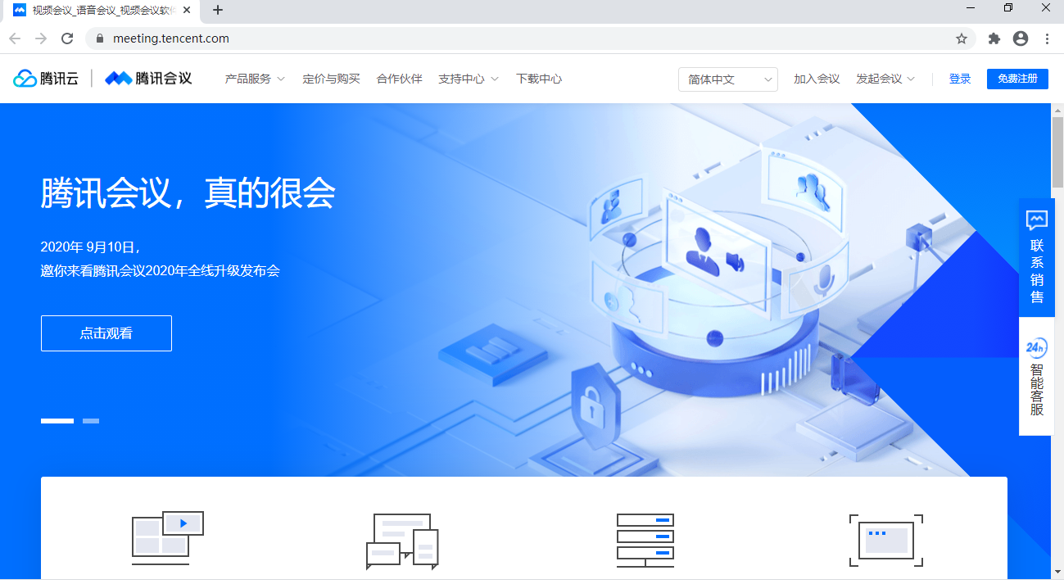
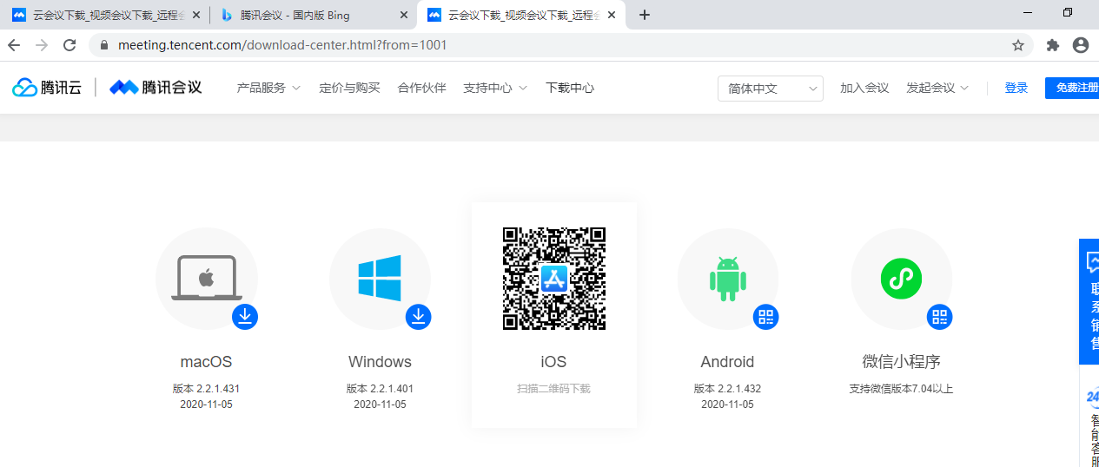
- 安装
找到下载好的腾讯会议安装包，双击安装包进行安装。安装完成后桌面会出现腾讯会议软件图标。
- 使用腾讯会议
- 登录
首次登录需要注册，然后使用注册的用户名和密码登录腾讯会议，也可以直接点击加入会议按钮，通过手机短信验证登入。

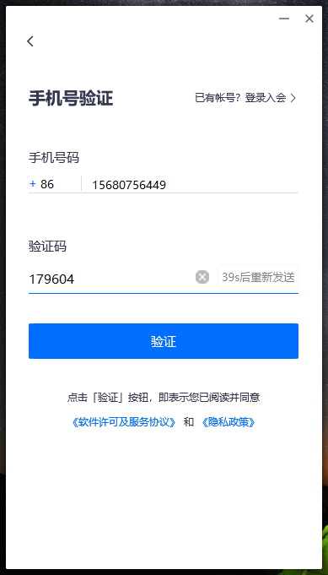
（成功加入会议）
- 使用
  - 解除静音
点击左下角“解除静音”图标开启或关闭麦克风，发言时请保持麦克风为开启状态。
  - 开启视频
点击左下角“开启视频”图标可以开启或关闭视频模式，如果愿意和大家面对面交流可以开启视频模式。
  - 共享屏幕
点击左下角“共享屏幕”图标可以选择桌面或者其他窗口进行共享。若看不到顶部结束共享按钮，可以把鼠标移至顶部中间“腾讯会议”字符框内，点击鼠标左键就可以显示“结束共享”按钮。
  - 结束共享屏幕
每一位主讲人结束报告后需要点击屏幕上方结束共享按钮，否则将会影响下一位主讲人的屏幕共享。
如果上一个主讲人忘记结束共享，主持人可以通过点击“共享屏幕”图标右侧的上箭头并选择“停止当前的共享”。

How to use VooV Meeting?
- Download
- Access the link https://voovmeeting.com/index.html to visit the VooV Meeting’s home page.
- Click on the “Download Center” menu bar, scroll down the page.
- Select VooV Meeting suitable for your computer system, and click to download the installation package.

- Install
- Find the downloaded installation package and double-click it to install VooV Meeting.
- After the installation is finished, the VooV Meeting application icon will appear on the desktop.

- Join a meeting
- Login and Join the meeting
You need to register for the first login, and then use the registered user name and password to log into VooV meeting, or you can click the “Join Meeting” button to directly join the meeting through SMS verification.
- Join the meeting
Before joining the meeting, you need to enter meeting id and your name correctly.

- Key operations
- Unmute
Click the “Unmute” icon in the lower left corner to turn on or off the microphone. Please keep the microphone on when you speak.
- Start Video
Click the “Start Video” icon in the lower left corner to turn on or off the video mode. If you are willing to communicate face-to-face with other participants, you could turn on the video mode.
- Share Screen
Click the “Share Screen” icon in the lower left corner to select the desktop or other windows to show for others.
- Stop sharing screen
In order to prevent the screen sharing of the next speaker from being affected, each speaker is required to click the “Stop Share” button at the top of the screen after finishing the report. If you can not see the button, just move the mouse to the “VooV Meeting” font icon at the top of the middle and click the left mouse button, and the “Stop Share” button will appear.
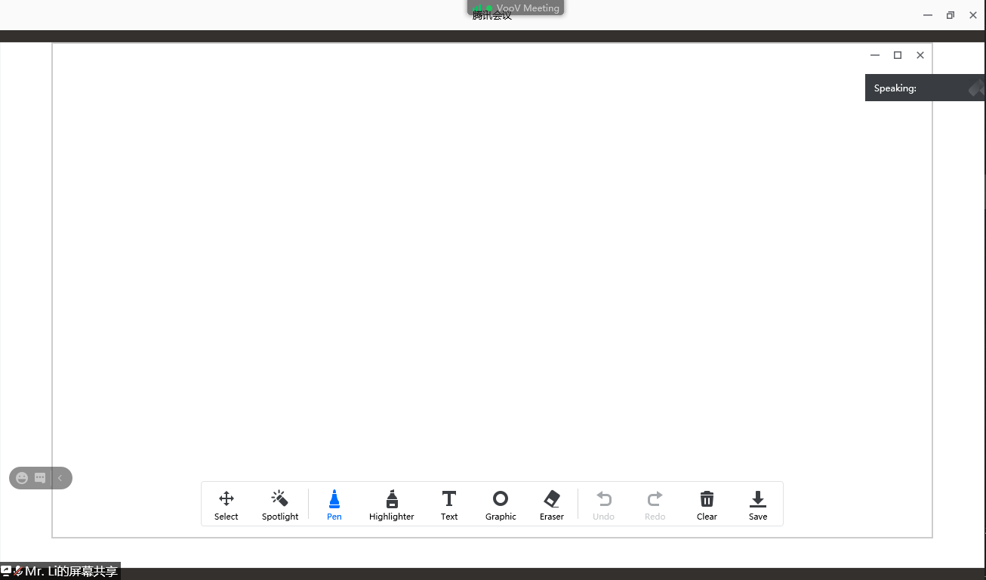

报告人住宿交通
（中国人民大学校内及燕山大酒店）
(1) The Capital International Airport 首都国际机场
地铁：乘坐机场快轨（三元桥方向），在三元桥站下车，换乘地铁十号线，到海淀黄庄站换乘地铁 4 号线，到人民大学站下车（A1 出口），步行至燕山大酒店或中国人民大学东门。
出租：打车约 100 元人民币。
(2) Beijing Daxing International Airport 北京大兴国际机场
地铁：乘坐北京大兴国际机场线（草桥方向），在草桥站下车，换乘地铁十号外环线（角门西方向），到角门西站换乘地铁 4 号线，到人民大学站下车（A1 出口），步行至燕山大酒店或中国人民大学东门。
出租：打车约 200 元人民币。
(3) Beijing Railway Station 北京站
地铁：乘坐地铁 2 号线（内环），在西直门站下车，换乘地铁 4 号线（安河桥北）方向，在人民大学站下车（A1 口出），步行至燕山大酒店或中国人民大学东门。
出租车：打车费用约 60 元人民币。
(4) Beijing West Railway Station 北京西站
地铁：出站后乘坐地铁 9 号线（国家图书馆方向），在国家图书馆站下车，换乘地铁 4 号线（安河桥北方向），在人民大学站下车，（A1 口出）。步行至燕山大酒店或中国人民大学东门。
出租：打车费用约为 35 元人民币。
(5) Beijing South Railway Station 北京南站：
地铁：乘坐地铁 4 号线（安河桥北方向），在人民大学站下车，（A1 口出），步行至中国人民大学东门。
出租：打车费用约为 60 元人民币。

人大校园，燕山大酒店及4号线人民大学站相对位置地图
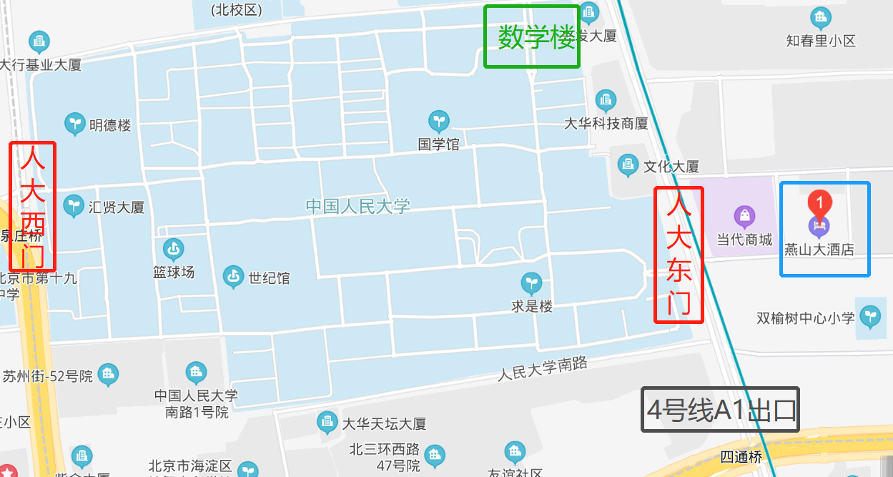

校外老师及学生参会指南

线上参会：
此次会议无注册费用，会议将采取报告人线下及线上结合的方式。欢迎海内外老师同学参会，建议大家使用腾讯会议参会，可直接参与讨论。备用听会地址为为腾讯会议直播及虎牙直播。链接如下：
- 腾讯会议/VooV meeting：
14日ID: 895437440, Passwd:1114 ; 15日ID: 827664470, passwd: 1115
- 虎牙直播地址： https://www.huya.com/bioinformatics
- 腾讯会议直播：
14日https://meeting.tencent.com/l/QLKpMLg2HZLQ
15日https://meeting.tencent.com/l/xe92cRen3t58

线下参会：
由于校园疫情防控，针对北京地区的同行老师和研究生，开放少量线下（人大校内）参会名额，如果想到会议现场，请简述个人研究领域，并提前（11月12日北京时间晚上8点前）给我们姓名、性别、身份证号、手机号等信息，发送信息到邮箱mialab_ruc@163.com 。成功申请的老师或同学，会收到邮件和短信通知，在会议当天可刷身份证进校参会。
注：线下参会需遵循当天校园防控要求

校内 Wi-Fi 使用指南
Step 1: 开启 Wi-Fi 接收，人大 Wi-Fi 名称前缀是 RUC_，打开浏览器，在地址栏中输入 go.ruc.edu.cn 并点击回车
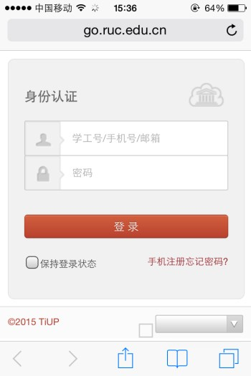

Step 2：点击 “手机注册”（左上图是电脑登录页面，右上图是手机登录页面）
Step 3：填写手机号，姓名，单位，验证码后点击“下一步”，手机会收到一条 4 位验证码的短信，点击右上角的“×”回到 Step 1 的页面，在“身份认证”第一栏输入手机号，第二栏输入刚收到的 4 位验证码，点击“登录”即连入 Wi-Fi。

